71st Melbourne Gang Show,
Family BBQ & Cub Sleepover!

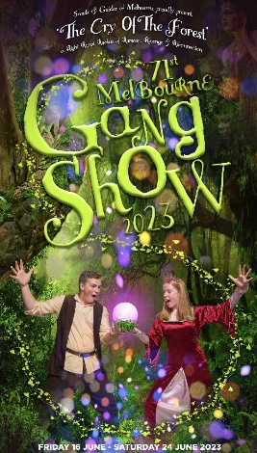
Saturday, June 17th, is our visit to Gang Show, our BBQ dinner and Cub Sleepover. This notice is being sent to those who are attending at least one of the 3 activities.

Gang Show
Full Uniform (or white scarf) to be worn.
For those going to Gang Show, you need to be at the Theatre: Besen Centre (on campus of
Mount Scopus College – see http://www.besencentre.com.au )
87-89 Station St, Burwood https://goo.gl/maps/FKJsY
- we suggest using Elgar Rd, rather than going past Box Hill Central.
…by 1:30pm, ready for the 2pm show – parking is always tight – arrive early!

…. NOTE that latecomers may not be allowed into the Theatre until intermission (half-time).

Please enter the front glass doors, turn Right and meet at the base of the Right Hand side staircase, to meet up with our Group before the Show and get your tickets. If you miss us, ask for your tickets at the Box Office.
For Cubs/Scouts attending without parents, please advise ASAP if you need help arranging transport.
The show goes for approx 2.5 hours. Afterwards we will return to the Hall.

Family BBQ
Following Gang Show, we’ll be having a BBQ at the Hall. Those not going to Gang Show, should arrive at the Hall at approx 5:30pm. Along with food, we’ll be providing ‘plain’ drinks (such as cordial). Parents please bring your own drinks if you want something different.
CUBS should bring a dilly bag for their badgework (cloth drawstring bag (with name on it) containing non-breakable plates / cup / cutlery / teatowel)
REMEMBER that the cost is $5 per head. Please ensure you pay me on the day if you have not already done so. If any BBQ or Sleepover Attendees have special dietary requirements, please notify us ASAP.

Cub Sleepover
Cubs staying for the Sleepover should bring/do:
- CareMonkey records checked/updated OR a Health Form (see our Website’s Paperwork/Download page) ** don’t forget!
- Stretcher or Air Mattress & Pump
- Sleeping bag, blanket and pillow
- Sleeping gear (PJs, slippers etc.) and some underwear for Sunday morning!
- Torch (check batteries)
- Toiletries/Towel/Toothbrush/paste as needed for overnight
- Supper and a light breakfast will be supplied to the Cubs.
- For those who haven’t yet paid, cost is $5 per Cub.
PICKUP – 8:15-8:45am Sunday!

Any queries, please contact:

Wayne (Akela)
0411 121 495
akela@rosannacubs.org

